Project Design Phase
Solution Architecture
Team ID | SWTID-2026-7816
Project Name | Auto Ticket Classification using Flow Designer
Maximum Marks | 4 Marks

Solution Architecture:
Solution architecture is a complex process – with many sub-processes – that bridges the gap between business problems and technology solutions. Its goals are to:
- Find the best tech solution to solve existing business problems.
- Describe the structure, characteristics, behavior, and other aspects of the software to project stakeholders.
- Define features, development phases, and solution requirements.
- Provide specifications according to which the solution is defined, managed, and delivered.

Solution Architecture Diagram:
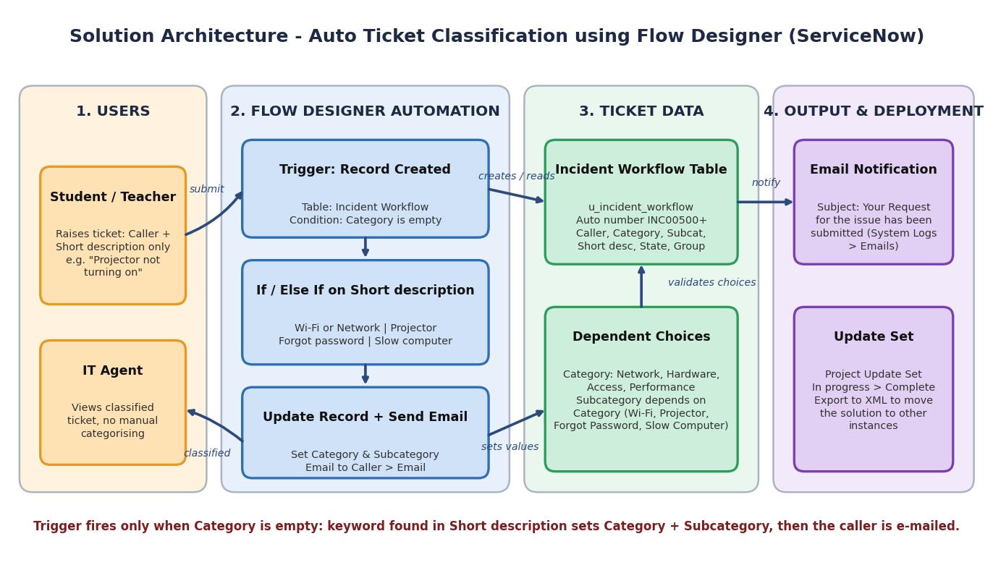
Figure 1: Architecture and data flow of the Auto Ticket Classification using Flow Designer project

Components and data flow:
- Ticket creation: a student or teacher opens a new record on the Incident Workflow form (u_incident_workflow) and enters only the Caller and Short description; the Number is generated automatically (prefix INC, 5 digits).
- Trigger: the flow Auto Classify School IT Tickets starts on Record Created for the Incident Workflow table when the Category is empty.
- Classification logic: If / Else If conditions check whether the Short description contains Wi-Fi or Network, Projector, Forgot password, or Slow computer.
- Update and notify: Update Record sets Category and Subcategory (Network / Wi-Fi, Hardware / Projector, Access / Forgot Password, Performance / Slow Computer) using dependent choices, then Send Email sends the confirmation “Your Request for the issue has been submitted.” to the Caller’s email; delivery is checked in System Logs > Emails.
- Deployment: all configuration is captured in the Project Update Set (Global), changed from In progress to Complete and exported to XML so it can be moved to another instance.
Technology stack: ServiceNow platform (Tables, Form Design, dependent choice fields, Flow Designer, Send Email action, Emails log, Update Sets).

